Lab 9
Repeat of DNS and DHCP

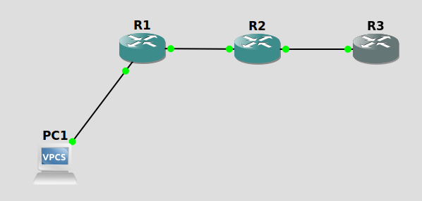
1. Ip configuration
PC1> ip 20.20.20.2/24
Checking for duplicate address...
PC1 : 20.20.20.2 255.255.255.0
PC1> ip 20.20.20.2 255.255.255.0 20.20.20.3
Checking for duplicate address...
PC1 : 20.20.20.2 255.255.255.0 gateway 20.20.20.3
R1(config)#interface f0/0
R1(config-if)#ip address 20.20.20.3 255.255.255.0
R1(config-if)#no shut
R1(config-if)#
*Mar 1 00:03:53.507: %LINK-3-UPDOWN: Interface FastEthernet0/0, changed state to up
*Mar 1 00:03:54.507: %LINEPROTO-5-UPDOWN: Line protocol on Interface FastEthernet0/0, changed state to up
R1(config-if)#interface f0/1
R1(config-if)#ip address 30.30.30.2 255.255.255.0
R1(config-if)#no shut
R1(config-if)#ip rout
*Mar 1 00:05:01.063: %LINK-3-UPDOWN: Interface FastEthernet0/1, changed state to up
*Mar 1 00:05:02.063: %LINEPROTO-5-UPDOWN: Line protocol on Interface FastEthernet0/1, changed state to up
R1(config-if)#ip route 40.40.40.0 255.255.255.0 30.30.30.3
R1(config)#exit
R1#
*Mar 1 00:06:10.487: %SYS-5-CONFIG_I: Configured from console by console
R1#copy run start
Destination filename [startup-config]?
Building configuration...
[OK]
R2(config)#inter f0/0
R2(config-if)#ip address 30.30.30.3 255.255.255.0
R2(config-if)#no shut
R2(config-if)#inter f0/1
*Mar 1 00:07:11.995: %LINK-3-UPDOWN: Interface FastEthernet0/0, changed state to up
*Mar 1 00:07:12.995: %LINEPROTO-5-UPDOWN: Line protocol on Interface FastEthernet0/0, changed state to up
R2(config-if)#inter f0/1
R2(config-if)#ip address 40.40.40.2 255.255.255.0
R2(config-if)#no shut
R2(config-if)#ip route 20
*Mar 1 00:08:01.443: %LINK-3-UPDOWN: Interface FastEthernet0/1, changed state to up
*Mar 1 00:08:02.443: %LINEPROTO-5-UPDOWN: Line protocol on Interface FastEthernet0/1, changed state to up
R2(config-if)#ip route 20.20.20.0 255.255.255.0 30.30.30.2
R2(config)#exit
R2#
*Mar 1 00:08:16.987: %SYS-5-CONFIG_I: Configured from console by console
R2#copy run start
Destination filename [startup-config]?
Building configuration...
[OK]
R3#conf t
Enter configuration commands, one per line. End with CNTL/Z.
R3(config)#inter f0/0
R3(config-if)#ip address 40.40.40.3 255.255.255.0
R3(config-if)#no shut
R3(config-if)#ip route 20.2
*Mar 1 00:08:46.311: %LINK-3-UPDOWN: Interface FastEthernet0/0, changed state to up
*Mar 1 00:08:47.311: %LINEPROTO-5-UPDOWN: Line protocol on Interface FastEthernet0/0, changed state to up
R3(config-if)#ip route 20.20.20.0 255.255.255.0 40.40.40.2
R3(config)#ip route 30.30.30.0 255.255.255.0 40.40.40.2
R3(config)#exit
R3#
*Mar 1 00:09:37.963: %SYS-5-CONFIG_I: Configured from console by console
R3#copy run start
Destination filename [startup-config]?
Building configuration...
[OK]

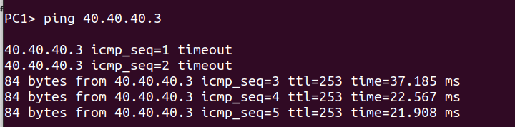
2. DNS Configuration

PC1> ip dns 40.40.40.3
R3#conf t
Enter configuration commands, one per line. End with CNTL/Z.
R3(config)#ip dns server
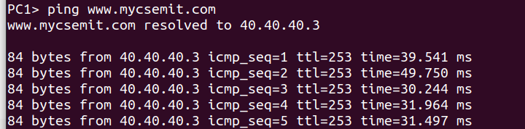
R3(config)#ip host www.mycsemit.com 40.40.40.3
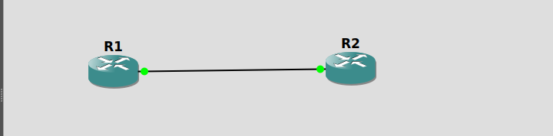
R1 ip configurations
R1#conf t
Enter configuration commands, one per line. End with CNTL/Z.
R1(config)#hostname R1
R1(config)#inter f0/0
R1(config-if)#ip address 10.10.10.1 255.255.255.0
R1(config-if)#no shut
R1(config-if)#do wr
Building configuration...
[OK]
R1(config-if)#end
*Mar 1 00:00:53.263: %LINK-3-UPDOWN: Interface FastEthernet0/0, changed state to up
*Mar 1 00:00:54.315: %LINEPROTO-5-UPDOWN: Line protocol on Interface FastEthernet0/0, changed state to up
R1(config-if)#end
R1#
*Mar 1 00:00:59.151: %SYS-5-CONFIG_I: Configured from console by console

R2 ip configurations
R2#config t
Enter configuration commands, one per line. End with CNTL/Z.
R2(config)#hostname R2
R2(config)#inter f0/0
R2(config-if)#ip address 10.10.10.2 255.255.255.0
R2(config-if)#no shut
R2(config-if)#do wr
Building configuration...
[OK]
R2(config-if)#
*Mar 1 00:03:25.047: %LINK-3-UPDOWN: Interface FastEthernet0/0, changed state to up
*Mar 1 00:03:26.235: %LINEPROTO-5-UPDOWN: Line protocol on Interface FastEthernet0/0, changed state to up
R2(config-if)#end
R2#
*Mar 1 00:03:31.043: %SYS-5-CONFIG_I: Configured from console by console

R2 DNS configurations
R2#conf t
Enter configuration commands, one per line. End with CNTL/Z.
R2(config)#ip dns server
R2(config)#ip host loopback.R2.com 2.2.2.2
R2(config)#interface loopback 1
R2(config-if)#i
*Mar 1 00:04:52.623: %LINEPROTO-5-UPDOWN: Line protocol on Interface Loopback1, changed state to up
R2(config-if)#ip address 2.2.2.2 255.255.255.255
R2(config-if)#end
R2#
*Mar 1 00:05:05.327: %SYS-5-CONFIG_I: Configured from console by console

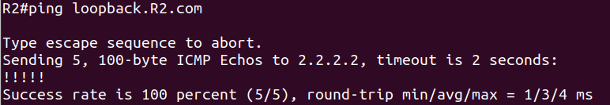
R1#conf t
Enter configuration commands, one per line. End with CNTL/Z.
R1(config)#ip domain lookup
R1(config)#ip name-server 10.10.10.2
R1(config)#ip route 0.0.0.0 0.0.0.0 10.10.10.2
R1(config)#end

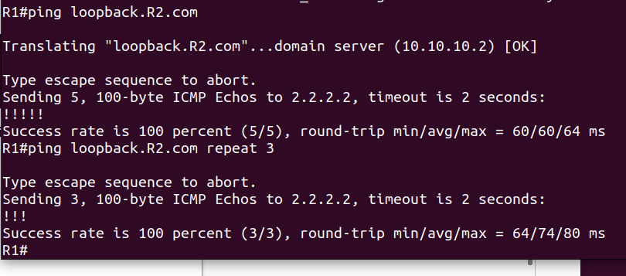
DHCP
Design the Network as shown for DHCP and DNS Configuration in R3.
A. Change the hostnames of the router to NAME-1, NAME-2 and NAME-3
B. Configure the IP Addresses to the interfaces on the router R1. (Use the last Host addresses)
C. Configure appropriate IP Addresses to the interfaces on R2 and R3.
NAME-1(config)#hostname SHREYA-1
SHREYA-1(config)#inter f0/0
SHREYA-1(config-if)#ip address 192.168.10.254 255.255.255.0
SHREYA-1(config-if)#no shut
SHREYA-1(config-if)#
*Mar 1 00:03:45.607: %LINK-3-UPDOWN: Interface FastEthernet0/0, changed state to up
*Mar 1 00:03:46.607: %LINEPROTO-5-UPDOWN: Line protocol on Interface FastEthernet0/0, changed state to up
SHREYA-1(config-if)#inter f0/1
SHREYA-1(config-if)#ip address 172.16.0.254 255.255.0.0
SHREYA-1(config-if)#no shut
SHREYA-1(config-if)#inter
*Mar 1 00:04:47.963: %LINK-3-UPDOWN: Interface FastEthernet0/1, changed state to up
*Mar 1 00:04:48.963: %LINEPROTO-5-UPDOWN: Line protocol on Interface FastEthernet0/1, changed state to up
SHREYA-1(config-if)#inter Serial1/0
SHREYA-1(config-if)#ip address 30.30.30.1 255.255.255.224
SHREYA-1(config-if)#no shut
SHREYA-1(config-if)#
*Mar 1 00:06:56.975: %LINK-3-UPDOWN: Interface Serial1/0, changed state to up
R2#conf t
Enter configuration commands, one per line. End with CNTL/Z.
R2(config)#hostname NAME-2
NAME-2(config)#hostname SHREYA-2
SHREYA-2(config)#inter s1/0
SHREYA-2(config-if)#ip address 20.20.20.1 255.255.255.240
SHREYA-2(config-if)#no shut
SHREYA-2(config-if)#
*Mar 1 00:10:37.879: %LINK-3-UPDOWN: Interface Serial1/0, changed state to up
SHREYA-2(config-if)#
*Mar 1 00:10:38.883: %LINEPROTO-5-UPDOWN: Line protocol on Interface Serial1/0, changed state to up
R3#conf t
Enter configuration commands, one per line. End with CNTL/Z.
R3(config)#hostname NAME-3
NAME-3(config)#hostname SHREYA-3
SHREYA-3(config)#inter s1/0
SHREYA-3(config-if)#ip addres 20.20.20.3 255.255.255.240
SHREYA-3(config-if)#no shutdown
SHREYA-3(config-if)#
*Mar 1 00:10:43.307: %LINK-3-UPDOWN: Interface Serial1/0, changed state to up
SHREYA-3(config-if)#
*Mar 1 00:10:44.311: %LINEPROTO-5-UPDOWN: Line protocol on Interface Serial1/0, changed state to up
SHREYA-3(config-if)#
*Mar 1 00:11:06.455: %LINEPROTO-5-UPDOWN: Line protocol on Interface Serial1/0, changed state to down

D. Configure Static Routing on the routers. (Assign Static IP Address to PC2 to check connectivity
to R3)
SHREYA-1(config)#ip route 20.20.20.0 255.255.255.240 30.30.30.2
SHREYA-2(config-if)#ip route 192.168.10.0 255.255.255.0 30.30.30.1
SHREYA-2(config)#ip route 172.16.0.0 255.255.0.0 30.30.30.1
SHREYA-3(config-if)#ip route 192.168.10.0 255.255.255.0 20.20.20.1
SHREYA-3(config)#ip route 192.168.10.0 255.255.255.0 20.20.20.1
SHREYA-3(config)#ip route 172.16.0.0 255.255.0.0 20.20.20.1
SHREYA-3(config)#ip route 30.30.30.0 255.255.255.224 20.20.20.1
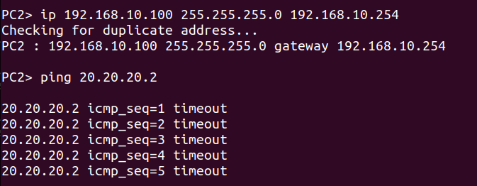
E. Configure R3 as the DNS Server with the Domain Name www.NAME.com. ( Test using PC2)
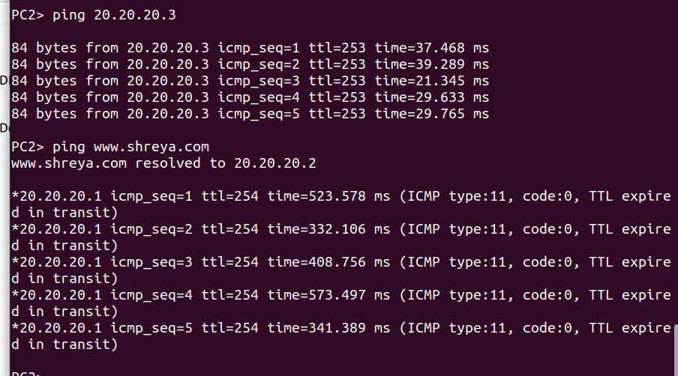

F. Configure R3 as the DHCP router with the following restrictions:
o Use name POOL-CLASS-C for the hosts in the 192.168.10.0/24 Network.
o Use name POOL-CLASS-B for the hosts in the 172.16.8.0/16 Network.
o Exclude the first and the last host addresses.
o Assign the DNS Server address during IP Configuration.
G. Assign appropriate DHCP relay agents.
H. Test IP Configuration in hosts and Access to the DNS Server.
I. Save the configurations on all routers.

